### **Networked Computers Simulation Evaluation/Interpretation**

**Group members:**

Reza Aurelio Brilliasah - 21/475039/PA/20515

Ahmad Fadhil Bukhori - 21/475083/PA/20525

Muhammad Zaky Firdaus **-** 21/477171/PA/20637

### Performance of the Network

1. **PC1 to PC2 Ping Testing**

|  |  |
| --- | --- |
| **Ping Testing PC1 to PC2** | |
| **Packet No.** | **Latency (ms)** |
| 1 | 0.163 |
| 2 | 0.180 |
| 3 | 0.161 |
| 4 | 0.193 |
| 5 | 0.183 |
| **Average** | **0.176** |

1. **POS to Main Server Ping Testing**

|  |  |
| --- | --- |
| **Ping Testing POS to Main Server** | |
| **Packet No.** | **Latency (ms)** |
| 1 | 0.168 |
| 2 | 0.184 |
| 3 | 0.231 |
| 4 | 0.203 |
| 5 | 0.254 |
| **Average** | **0.208** |

1. **PC to Router Ping Testing**

|  |  |
| --- | --- |
| **Ping Testing PC to Router** | |
| **Packet No.** | **Latency (ms)** |
| 1 | 9.458 |
| 2 | 10.942 |
| 3 | 1.719 |
| 4 | 2.204 |
| 5 | 4.198 |
| **Average** | **5.7042** |

1. **Performance Interpretation**

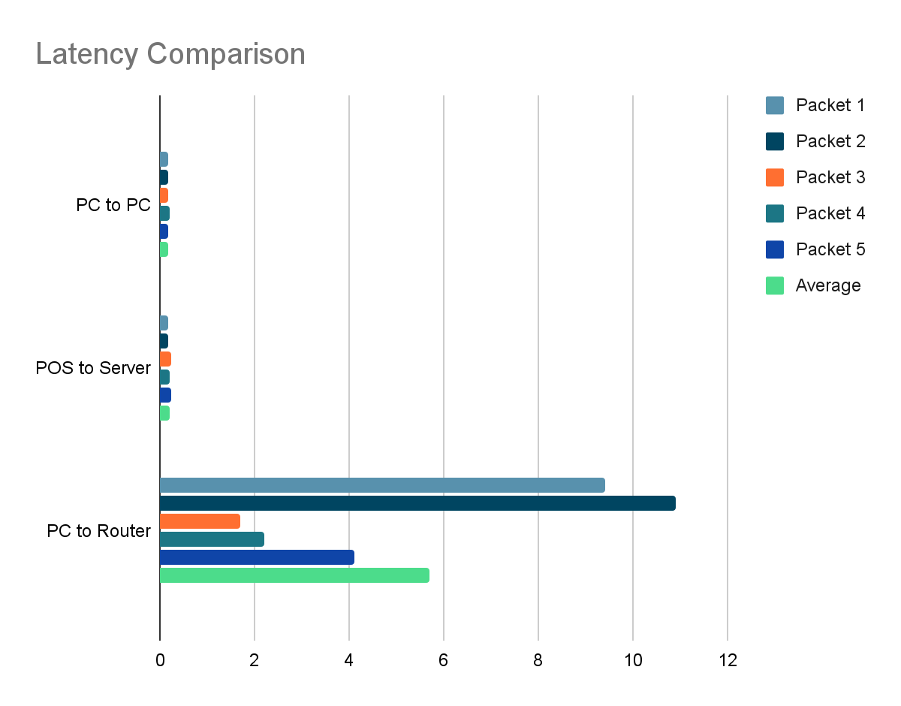

Looking at the graph above, the average latency of ping testing from PC1 to PC2 is 0.176 ms. The average latency of ping testing from POS to Main server is 0.208 ms, while the average latency of ping testing from PC to Router is 5.7042 ms. In addition to the speeds, no packages have been lost during transfer. All of the pings issued by a computer pings the correct device. Each ping response sent a total of 5 packages, all which have been received properly by the issuing computer. The success rate of the ping test from the router to the internet also has a 100% success rate. During the PC to Router ping test, the latency varies with the highest being 10.942 ms and the lowest 1.719 ms. This latency variety might happen due to several reasons, such as traffic, load on pinged devices, or devices that are passed by packet. In a study published in the International Journal of Computer Applications, it is found that the average ping latency on a simulated computer network with a star topology averaged at 0.0004 seconds, or 0.4 milliseconds (Absar, N). As the result obtained in this research is lower than this average, it can be concluded that the networked design meets the standards of similar designs in terms of network speed.

### Security

The computer network being designed theoretically fulfills the security requirements. Having a backup server will allow the data to be safeguarded in case the normal server encounters some issues. The firewall will also prevent unauthorized access into or out of a computer network. In addition, adding DHCP to the router’s interface connected to the internet will aid in preventing hackers from hacking the router.

### Limitations of the Simulation

There are several limitations to the networked computer simulation presented in this paper. For instance, all of the devices on the simulation are all simulated using VPCs or Virtual Personal Computers. The servers, POS systems, id card readers, etc. are all simulated as VPCs. While this approach provides a general simulation of the real-case scenario, it is still not a 1:1 comparison. In addition, there is another component, the firewall, that is still unable to work in the simulation. In the simulation, the firewall is actually not connected to the network but the firewall component is just placed on top of the cable. Another limitation is the connectivity of the VPCs. As they only allow a single connection to be made, this made simulating the printers difficult as there was no method to connect them directly to the POS system simulated as a VPC. To work around this, we are assuming the printer is already a component of the POS system.

### Possible Improvements

From the simulation that has been simulated, what can be improved is implementing more devices into the network using their respective software images. This would include implementing real servers, firewalls, POS systems, scanners, printers, and modems into the network as opposed to only virtual pcs.

As for the design of the network, there are several improvements that could be made to make the network more efficient and optimized, especially if the number of devices connected to the network were to be increased. A main disadvantage of Star Topology and Extended star topology is that the network is highly dependent on the central device. As a result, this device were to encounter some issues that would prevent it from working, then the network would not be able to operate. As such, it would be more optimal if instead of one device as the core, several devices connected together would act as a core. This would allow the network to still operate even when one of the core devices is down.

### Conclusion

The implementation of the proposed computer network for the pet shop would result in a positive impact for the business. By using a computer network for the pet shop, it is more efficient and also it could reduce cost. The data of the petshop can be easily shared to different users. Computer networks can also connect computers, printers, id card readers, etc. By having it connected to each other and having the data in one database, it could reduce the cost. The average performance of the ping testing from PC to the router showed the highest with the average speed of 5.7042 ms. Each ping testing sends 5 packets to their respective destinations and all ping testing has a 100% success rate, so it can be concluded that the network is reliable for sending data from one computer to another. In addition, all of the computers are connected through a high-performance and fast connection. Most device-to-device communications will take less than 1ms, which is incredibly fast. In addition, the implementation of a firewall and backup server will provide security to the Pet Shop.

**References**

[1] Absar, N., Jahangir Alam, M. and Ahmed, T., 2014. Performance Study of Star Topology in Small Internetworks. *International Journal of Computer Applications*, 107(2), pp.45-53.